**Novērtēšanas plāns sabalansētai ēdienkartei**

**Mērķis:**  
Novērtēt uztura plāna precizitāti un optimizācijas efektivitāti, balstoties uz lietotāja prasībām un produktu datiem.

**Ieejas mainīgie:**

* **Datu apjoms (N):** Produktu skaits datubāzē (piem., 100, 150, 175 produkti).
* **Diētas tips (V):**
  + **A: Dzīvnieku izcelsmes diēta (Animal-based diet)** – Yes Vegan
  + **B: Augu izcelsmes diēta (Plant-based diet)** – No Vegan
  + **C: Visēdāja diēta (Omnivore diet) –** Visi produkti bez ierobežojumiem.

**Novērtēšanas mēri:**

* **Precizitāte (P, %):** Pārbaudīt, cik labi uztura plāns atbilst kaloriju un uzturvielu prasībām.
* **Aprēķina laiks (T_A, sekundes):** Laiks, kas nepieciešams optimizācijas algoritma izpildei.
* **Pielāgojamības ātrums (T_R, sekundes):** Laiks, kas vajadzīgs izmaiņu veikšanai prasībās.

1.NR  
 **N = 100  
V = A**

**P**

**1)**

**P_kalorijas = (1 - |1573.94 - 1698.10| / 1573.94) × 100 ≈ 92.12%  
P_proteini = (1 - |92.30 - 83.07| / 92.30) × 100 ≈ 90.00%  
P_tauki = (1 - |52.46 - 62.95| / 52.46) × 100 ≈ 79.93%  
P_oglhidrati = (1 - |196.74 - 236.09| / 196.74) × 100 ≈ 79.94%  
P = (92.12 + 90.00 + 79.93 + 79.94) / 4 ≈ 85.00%**

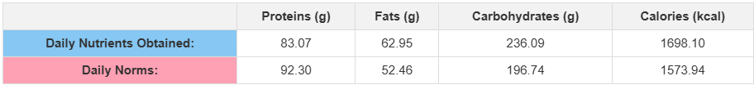

**2)**

**P_kalorijas = (1 - |1573.94 - 1700.67| / 1573.94) × 100 ≈ 91.95%  
P_proteini = (1 - |92.30 - 83.07| / 92.30) × 100 ≈ 90.01%  
P_tauki = (1 - |52.46 - 62.95| / 52.46) × 100 ≈ 80.00%  
P_oglhidrati = (1 - |196.74 - 236.09| / 196.74) × 100 ≈ 80.00%**

**P = (91.95 + 90.01 + 80.00 + 80.00) / 4 ≈ 85.49%**

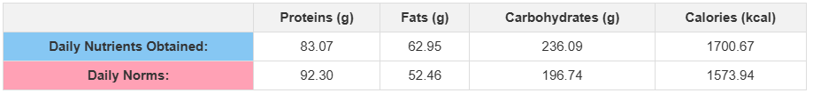

**3)**

**P_kalorijas = (1 - |1573.94 - 1595.75| / 1573.94) × 100 ≈ 98.61%  
P_proteini = (1 - |92.30 - 83.07| / 92.30) × 100 ≈ 89.99%  
P_tauki = (1 - |52.46 - 52.81| / 52.46) × 100 ≈ 99.33%  
P_oglhidrati = (1 - |196.74 - 236.09| / 196.74) × 100 ≈ 80.00%**

**P = (98.61 + 89.99 + 99.33 + 80.00) / 4 ≈ 91.48%**

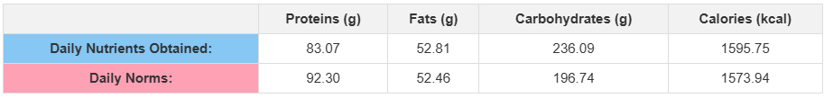

**V)  
87,32 %**

**1)  
T_A = 119 ms, 109 ms, 114 ms V 114 ms**

**T_R = 54 ms, 50 ms, 54 ms V 52,6 ms**

**2)  
T_A = 128 ms, 121 ms, 106 ms V 118,3 ms**

**T_R = 56 ms, 54 ms, 56 ms V 55,3 ms**

**3)  
T_A = 116 ms, 147 ms, 140 ms V 134,3 ms**

**T_R = 52 ms, 65 ms, 56 ms V 57,6 ms**

**V)  
T_A = V 122,2 ms 0,122 s  
T_R = V 55,2 ms 0,055 s**

2.NR  
 **N = 150  
V = A**

**P**

**1)**

**P_kalorijas = (1 - |1573.94 - 1595.75| / 1573.94) × 100 ≈ 98.61%  
P_proteini = (1 - |92.30 - 83.07| / 92.30) × 100 ≈ 89.99%  
P_tauki = (1 - |52.46 - 52.81| / 52.46) × 100 ≈ 99.33%  
P_oglhidrati = (1 - |196.74 - 236.09| / 196.74) × 100 ≈ 79.94%**

**P = (98.61 + 89.99 + 99.33 + 79.94) / 4 ≈ 91.97%**

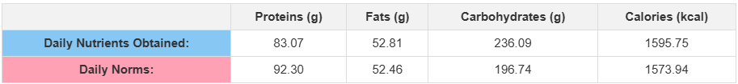

**2)**

**P_kalorijas = (1 - |1573.94 - 1688.97| / 1573.94) × 100 ≈ 92.70%  
P_proteini = (1 - |92.30 - 83.07| / 92.30) × 100 ≈ 91.99%  
P_tauki = (1 - |52.46 - 62.95| / 52.46) × 100 ≈ 80.00%  
P_oglhidrati = (1 - |196.74 - 236.09| / 196.74) × 100 ≈ 80.00%**

**P = (92.70 + 91.99 + 80.00 + 80.00) / 4 ≈ 86.17%**

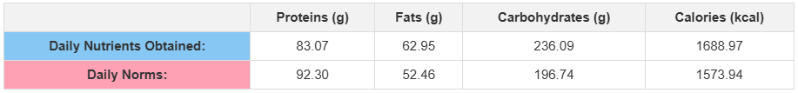

**3)**

**P_kalorijas = (1 - |1573.94 - 1726.80| / 1573.94) × 100 ≈ 89.29%  
P_proteini = (1 - |92.30 - 83.07| / 92.30) × 100 ≈ 91.99%  
P_tauki = (1 - |52.46 - 62.97| / 52.46) × 100 ≈ 79.93%  
P_oglhidrati = (1 - |196.74 - 236.09| / 196.74) × 100 ≈ 80.00%**

**P = (89.29 + 91.99 + 79.93 + 80.00) / 4 ≈ 85.30%**

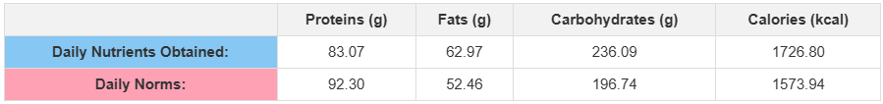

**V)  
87,81  
  
1)  
T_A = 137 ms, 185 ms, 143 ms V 155 ms**

**T_R = 56 ms, 57 ms, 59 ms V 57,3 ms**

**2)  
T_A = 107 ms, 109 ms, 136 ms V 117,3 ms**

**T_R = 56 ms, 57 ms, 65 ms V 59,3 ms**

**3)  
T_A = 107 ms, 109 ms, 129 ms V 115 ms**

**T_R = 50 ms, 51 ms, 62 ms V 54,3 ms  
  
V)**

**T_A = V 129,1 ms 0,129 s**

**T_R = V 57 ms 0,057 s**

3.NR  
 **N = 175  
V = A**

**P**

**1)**

**P_kalorijas = (1 - |1573.94 - 1688.97| / 1573.94) × 100 ≈ 92.70%  
P_proteini = (1 - |92.30 - 83.07| / 92.30) × 100 ≈ 91.99%  
P_tauki = (1 - |52.46 - 62.95| / 52.46) × 100 ≈ 80.01%  
P_oglhidrati = (1 - |196.74 - 236.09| / 196.74) × 100 ≈ 80.00%**

**P = (92.70 + 91.99 + 80.01 + 80.00) / 4 ≈ 86.18%**

**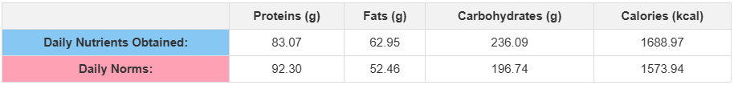  
  
2)**

**P_kalorijas = (1 - |1573.94 - 1700.67| / 1573.94) × 100 ≈ 92.95%  
P_proteini = (1 - |92.30 - 83.07| / 92.30) × 100 ≈ 91.99%  
P_tauki = (1 - |52.46 - 62.95| / 52.46) × 100 ≈ 80.01%  
P_oglhidrati = (1 - |196.74 - 236.09| / 196.74) × 100 ≈ 80.00%**

**P = (92.95 + 91.99 + 80.01 + 80.00) / 4 ≈ 86.24%**

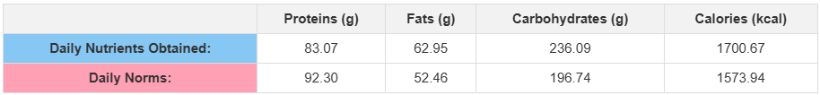

**3)**

**P_kalorijas = (1 - |1573.94 - 1688.97| / 1573.94) × 100 ≈ 92.69%  
P_proteini = (1 - |92.30 - 83.07| / 92.30) × 100 ≈ 91.99%  
P_tauki = (1 - |52.46 - 62.95| / 52.46) × 100 ≈ 80.01%  
P_oglhidrati = (1 - |196.74 - 236.09| / 196.74) × 100 ≈ 80.00%**

**P = (92.69 + 91.99 + 80.01 + 80.00) / 4 ≈ 86.17%**

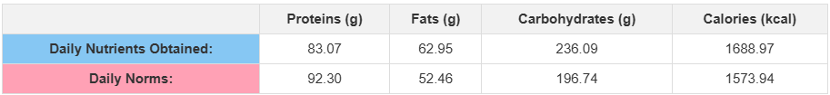

**V)  
86,20   
  
1)  
T_A = 129 ms, 129 ms, 103 ms V 120,3 ms**

**T_R = 50 ms, 45 ms, 74 ms V 56,3 ms  
  
2)  
T_A = 114 ms, 115 ms, 152 ms V 127 ms**

**T_R = 52 ms, 55 ms, 66 ms V 57,6 ms  
  
3)  
T_A = 123 ms, 113 ms, 112 ms V 112 ms**

**T_R = 53 ms, 56 ms, 70 ms V 59,6 ms**

**V)  
T_A = V 119,8 ms 0,120 s**

**T_R = V 57,8 ms 0,058 s**

4.NR  
  
**N = 100  
V = B**

**P**

**1)**

**P_kalorijas = (1 - |1573.94 - 1712.07| / 1573.94) × 100 ≈ 89.00%  
P_proteini = (1 - |92.30 - 83.07| / 92.30) × 100 ≈ 90.00%  
P_tauki = (1 - |52.46 - 47.22| / 52.46) × 100 ≈ 91.02%  
P_oglhidrati = (1 - |196.74 - 236.08| / 196.74) × 100 ≈ 79.92%  
P = (89.00 + 90.00 + 91.02 + 79.92) / 4 ≈ 87.49%**

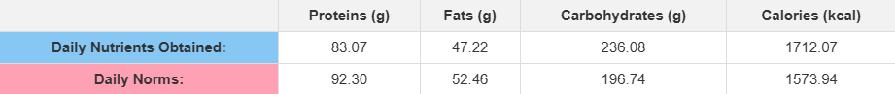

**2)**

**P_kalorijas = (1 - |1573.94 - 1416.54| / 1573.94) × 100 ≈ 91.00%  
P_proteini = (1 - |92.30 - 83.08| / 92.30) × 100 ≈ 89.99%  
P_tauki = (1 - |52.46 - 47.21| / 52.46) × 100 ≈ 89.99%  
P_oglhidrati = (1 - |196.74 - 236.09| / 196.74) × 100 ≈ 80.00%**

**P = (91.00 + 89.99 + 89.99 + 80.00) / 4 ≈ 87.25%**



**3)**

**P_kalorijas = (1 - |1573.94 - 1580.98| / 1573.94) × 100 ≈ 99.55%  
P_proteini = (1 - |92.30 - 83.07| / 92.30) × 100 ≈ 89.99%  
P_tauki = (1 - |52.46 - 47.22| / 52.46) × 100 ≈ 90.01%  
P_oglhidrati = (1 - |196.74 - 208.40| / 196.74) × 100 ≈ 94.07%**

**P = (99.55 + 89.99 + 90.01 + 94.07) / 4 ≈ 93.91%**

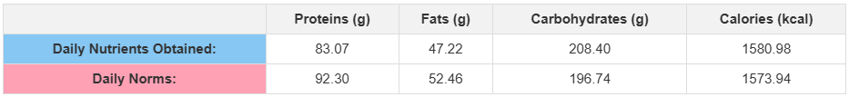

**V)  
89,55  
  
1)  
T_A = 116 ms, 100 ms, 105 ms V 107 ms**

**T_R = 53 ms, 66 ms, 64 ms V 61 ms**

**2)  
T_A = 126 ms, 119 ms, 97 ms V 114 ms**

**T_R = 56 ms, 54 ms, 53 ms V 54,3 ms**

**3)  
T_A = 96 ms, 96 ms, 97 ms V 96 ms**

**T_R = 49 ms, 67 ms, 53 ms V 56,3 ms  
  
V)  
T_A = V 105,6 ms 0,106 s**

**T_R = V 57,2 ms 0,057 s**

5.NR  
 **N = 150  
V = B**

**P**

**1)**

**P_kalorijas = (1 - |1573.94 - 1539.54| / 1573.94) × 100 ≈ 97.81%  
P_proteini = (1 - |92.30 - 83.07| / 92.30) × 100 ≈ 89.99%  
P_tauki = (1 - |52.46 - 47.22| / 52.46) × 100 ≈ 90.02%  
P_oglhidrati = (1 - |196.74 - 208.45| / 196.74) × 100 ≈ 94.04%**

**P = (97.81 + 89.99 + 90.02 + 94.04) / 4 ≈ 92.47%**

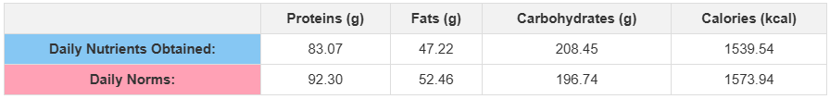

**2)**

**P_kalorijas = (1 - |1573.94 - 1707.73| / 1573.94) × 100 ≈ 91.48%  
P_proteini = (1 - |92.30 - 83.07| / 92.30) × 100 ≈ 91.99%  
P_tauki = (1 - |52.46 - 47.22| / 52.46) × 100 ≈ 90.01%  
P_oglhidrati = (1 - |196.74 - 236.09| / 196.74) × 100 ≈ 80.00%**

**P = (91.48 + 91.99 + 90.01 + 80.00) / 4 ≈ 88.37%**

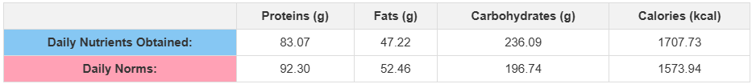

**3)**

**P_kalorijas = (1 - |1573.94 - 1580.98| / 1573.94) × 100 ≈ 99.55%  
P_proteini = (1 - |92.30 - 83.07| / 92.30) × 100 ≈ 89.99%  
P_tauki = (1 - |52.46 - 47.22| / 52.46) × 100 ≈ 90.01%  
P_oglhidrati = (1 - |196.74 - 208.40| / 196.74) × 100 ≈ 94.07%**

**P = (99.55 + 89.99 + 90.01 + 94.07) / 4 ≈ 93.91%**



**V)  
91,58  
  
1)  
T_A = 144 ms, 100 ms, 98 ms V 114 ms**

**T_R = 67 ms, 52 ms, 63 ms V 60,6 ms**

**2)  
T_A = 109 ms, 130 ms, 102 ms V 107 ms**

**T_R = 52 ms, 44 ms, 52 ms V 49,3 ms**

**3)  
T_A = 169 ms, 102 ms, 110 ms V 133 ms**

**T_R = 60 ms, 58 ms, 58 ms V 58,6 ms**

**V)  
T_A = V 118 ms 0,118 s**

**T_R = V 56,2 ms 0,056 s**

6.NR  
 **N = 175  
V = B**

**P**

**1)**

**P_kalorijas = (1 - |1573.94 - 1580.98| / 1573.94) × 100 ≈ 99.55%  
P_proteini = (1 - |92.30 - 83.07| / 92.30) × 100 ≈ 89.99%  
P_tauki = (1 - |52.46 - 47.22| / 52.46) × 100 ≈ 90.01%  
P_oglhidrati = (1 - |196.74 - 208.40| / 196.74) × 100 ≈ 94.07%**

**P = (99.55 + 89.99 + 90.01 + 94.07) / 4 ≈ 93.91%**



**2)**

**P_kalorijas = (1 - |1573.94 - 1580.98| / 1573.94) × 100 ≈ 99.55%  
P_proteini = (1 - |92.30 - 83.07| / 92.30) × 100 ≈ 89.99%  
P_tauki = (1 - |52.46 - 47.22| / 52.46) × 100 ≈ 90.01%  
P_oglhidrati = (1 - |196.74 - 208.40| / 196.74) × 100 ≈ 94.07%**

**P = (99.55 + 89.99 + 90.01 + 94.07) / 4 ≈ 93.91%**



**3)**

**P_kalorijas = (1 - |1573.94 - 1580.98| / 1573.94) × 100 ≈ 99.55%  
P_proteini = (1 - |92.30 - 83.07| / 92.30) × 100 ≈ 89.99%  
P_tauki = (1 - |52.46 - 47.22| / 52.46) × 100 ≈ 90.01%  
P_oglhidrati = (1 - |196.74 - 208.40| / 196.74) × 100 ≈ 94.07%**

**P = (99.55 + 89.99 + 90.01 + 94.07) / 4 ≈ 93.91%**

**  
  
V)  
93,91  
  
  
1)  
T_A = 97 ms, 110 ms, 111 ms V 106 ms**

**T_R = 56 ms, 48 ms, 51 ms V 51,6 ms**

**2)  
T_A = 105 ms, 260 ms, 96 ms V 168 ms**

**T_R = 54 ms, 86 ms, 58 ms V 66 ms**

**3)  
T_A = 114 ms, 127 ms, 122 ms V 121 ms**

**T_R = 67 ms, 66 ms, 55 ms V 62,6 ms  
  
V)  
  
T_A = V 131,6 ms 0,132 s**

**T_R = V 60,06 ms 0,06 s**7.NR  
**N = 100  
V = C**

**P**

**1)**

**P_kalorijas = (1 - |1573.94 - 1668.25| / 1573.94) × 100 ≈ 93.99%  
P_proteini = (1 - |92.30 - 83.07| / 92.30) × 100 ≈ 90.01%  
P_tauki = (1 - |52.46 - 47.22| / 52.46) × 100 ≈ 90.01%  
P_oglhidrati = (1 - |196.74 - 236.09| / 196.74) × 100 ≈ 80.00%**

**P = (93.99 + 90.01 + 90.01 + 80.00) / 4 ≈ 88.00%**

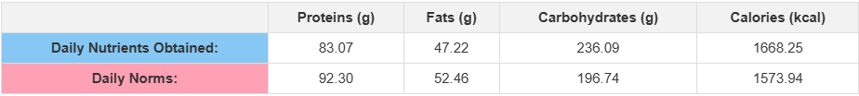

**2)**

**P_kalorijas = (1 - |1573.94 - 1512.97| / 1573.94) × 100 ≈ 96.12%  
P_proteini = (1 - |92.30 - 83.07| / 92.30) × 100 ≈ 89.99%  
P_tauki = (1 - |52.46 - 47.21| / 52.46) × 100 ≈ 89.99%  
P_oglhidrati = (1 - |196.74 - 208.14| / 196.74) × 100 ≈ 94.22%**

**P = (96.12 + 89.99 + 89.99 + 94.22) / 4 ≈ 92.08%**

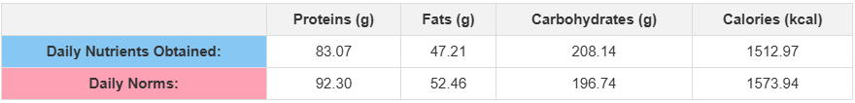

**3)**

**P_kalorijas = (1 - |1573.94 - 1580.98| / 1573.94) × 100 ≈ 99.55%  
P_proteini = (1 - |92.30 - 83.07| / 92.30) × 100 ≈ 89.99%  
P_tauki = (1 - |52.46 - 47.22| / 52.46) × 100 ≈ 90.01%  
P_oglhidrati = (1 - |196.74 - 208.40| / 196.74) × 100 ≈ 94.07%**

**P = (99.55 + 89.99 + 90.01 + 94.07) / 4 ≈ 93.91%**



**V)  
93,33**

**1)  
T_A = 104 ms, 148 ms, 117 ms V 123 ms**

**T_R = 60 ms, 47 ms, 57 ms V 54,6 ms**

**2)  
T_A = 88 ms, 107 ms, 122 ms V 105,6 ms**

**T_R = 52 ms, 53 ms, 56 ms V 53,6 ms**

**3)  
T_A = 115 ms, 97 ms, 116 ms V 109,3 ms**

**T_R = 52 ms, 57 ms, 63 ms V 57,3 ms**

**V)  
T_A = V 112,6 ms 0,113 s**

**T_R = V 55,2 ms 0,055 s**

8.NR  
 **N = 150  
V = C**

**P**

**1)**

**P_kalorijas = (1 - |1573.94 - 1539.54| / 1573.94) × 100 ≈ 97.81%  
P_proteini = (1 - |92.30 - 83.07| / 92.30) × 100 ≈ 89.99%  
P_tauki = (1 - |52.46 - 47.22| / 52.46) × 100 ≈ 90.02%  
P_oglhidrati = (1 - |196.74 - 208.45| / 196.74) × 100 ≈ 94.04%**

**P = (97.81 + 89.99 + 90.02 + 94.04) / 4 ≈ 92.47%**



**2)**

**P_kalorijas = (1 - |1573.94 - 1704.53| / 1573.94) × 100 ≈ 91.71%  
P_proteini = (1 - |92.30 - 83.07| / 92.30) × 100 ≈ 91.99%  
P_tauki = (1 - |52.46 - 47.22| / 52.46) × 100 ≈ 90.01%  
P_oglhidrati = (1 - |196.74 - 236.09| / 196.74) × 100 ≈ 80.00%**

**P = (91.71 + 91.99 + 90.01 + 80.00) / 4 ≈ 88.43%**

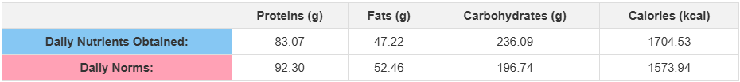

**3)**

**P_kalorijas = (1 - |1573.94 - 1580.98| / 1573.94) × 100 ≈ 99.55%  
P_proteini = (1 - |92.30 - 83.07| / 92.30) × 100 ≈ 89.99%  
P_tauki = (1 - |52.46 - 47.22| / 52.46) × 100 ≈ 90.01%  
P_oglhidrati = (1 - |196.74 - 208.40| / 196.74) × 100 ≈ 94.07%**

**P = (99.55 + 89.99 + 90.01 + 94.07) / 4 ≈ 93.91%**



**V)**

**91,60  
  
1)  
T_A = 105 ms, 101 ms, 106 ms V 104 ms**

**T_R = 52 ms, 59 ms, 50 ms V 53,6 ms**

**2)  
T_A = 137 ms, 113 ms, 99 ms V 116,3 ms**

**T_R = 47 ms, 51 ms, 68 ms V 55,3 ms**

**3)  
T_A = 126 ms, 99 ms, 88 ms V 104,3 ms**

**T_R = 59 ms, 59 ms, 85 ms V 67,6 ms  
  
V)  
T_A = V 108,2 ms 0,108 s**

**T_R = V 58,8 ms 0,059 s**

9.NR  
 **N = 175  
V = C**

**P**

**1)**

**P_kalorijas = (1 - |1573.94 - 1580.98| / 1573.94) × 100 ≈ 99.55%  
P_proteini = (1 - |92.30 - 83.07| / 92.30) × 100 ≈ 89.99%  
P_tauki = (1 - |52.46 - 47.22| / 52.46) × 100 ≈ 90.01%  
P_oglhidrati = (1 - |196.74 - 208.40| / 196.74) × 100 ≈ 94.07%**

**P = (99.55 + 89.99 + 90.01 + 94.07) / 4 ≈ 93.91%**



**2)**

**P_kalorijas = (1 - |1573.94 - 1580.98| / 1573.94) × 100 ≈ 99.55%  
P_proteini = (1 - |92.30 - 83.07| / 92.30) × 100 ≈ 89.99%  
P_tauki = (1 - |52.46 - 47.22| / 52.46) × 100 ≈ 90.01%  
P_oglhidrati = (1 - |196.74 - 208.40| / 196.74) × 100 ≈ 94.07%**

**P = (99.55 + 89.99 + 90.01 + 94.07) / 4 ≈ 93.91%**



**3)**

**P_kalorijas = (1 - |1573.94 - 1580.98| / 1573.94) × 100 ≈ 99.55%  
P_proteini = (1 - |92.30 - 83.07| / 92.30) × 100 ≈ 89.99%  
P_tauki = (1 - |52.46 - 47.22| / 52.46) × 100 ≈ 90.01%  
P_oglhidrati = (1 - |196.74 - 208.40| / 196.74) × 100 ≈ 94.07%**

**P = (99.55 + 89.99 + 90.01 + 94.07) / 4 ≈ 93.91%**



**V)**

**93,91  
  
1)  
T_A = 90 ms, 89 ms, 115 ms V 98 ms**

**T_R = 52 ms, 58 ms, 54 ms V 54,6 ms**

**2)  
T_A = 87 ms, 147 ms, 109 ms V 114,3 ms**

**T_R = 51 ms, 75 ms, 84 ms V 70 ms**

**3)  
T_A = 162 ms, 96 ms, 106 ms V 121,3 ms**

**T_R = 78 ms, 58 ms, 62 ms V 66 ms**

**V)**

**T_A = V 111,2 ms 0,111 s**

**T_R = V 63,5 ms 0,635 s**

**Novērtēšanas rezultāti**

|  |  |  |  |  |  |
| --- | --- | --- | --- | --- | --- |
| Nr | N | V | P | T_A | T_R |
| **1** | **100** | **A** | **87,32%** | **0,122 s** | **0,055 s** |
| **2** | **150** | **A** | **87,81%** | **0,129 s** | **0,057 s** |
| **3** | **175** | **A** | **86,20%** | **0,120 s** | **0,058 s** |
| **4** | **100** | **B** | **89,55%** | **0,106 s** | **0,057 s** |
| **5** | **150** | **B** | **91,58%** | **0,118 s** | **0,056 s** |
| **6** | **175** | **B** | **93,91%** | **0,132 s** | **0,060 s** |
| **7** | **100** | **C** | **93,33%** | **0,113 s** | **0,055 s** |
| **8** | **150** | **C** | **91,60%** | **0,108 s** | **0,059 s** |
| **9** | **175** | **C** | **93,91%** | **0,111 s** | **0,635 s** |

**Paskaidrojumi:**

* **P:** Uztura plāna precizitāte, izteikta procentos.
* **T_A:** Algoritma aprēķina laiks.
* **T_R:** Rezultātu pārrēķina ātrums pēc izmaiņām.

Šāda pieeja ļauj izvērtēt, kā dažādi uztura tipi un datu apjomi ietekmē optimizācijas precizitāti un ātrumu, palīdzot lietotājam pieņemt informētus lēmumus par uztura plāniem.